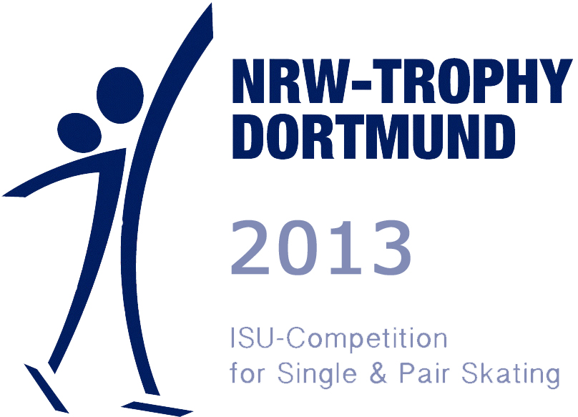 | This form must return before November 3rd, 201  PLANNED PROGRAM CONTENT  ISU-Competition for Single and Pair Skating  Dortmund, Germany  December 4th – December 8th, 2013

Skater / Pair | Surname | First Name
Category:

 | Elements SP |  |  | Elements FP
1 |  |  | 1
1 |  |  | 2
2 |  |  | 3
2 |  |  | 4
3 |  |  | 5
3 |  |  | 6
4 |  |  | 7
4 |  |  | 8
5 |  |  | 9
5 |  |  | 10
6 |  |  | 11
6 |  |  | 12
7 |  |  | 13
7 |  |  | 14
8 |  |  | 15
8 |  |  | 16

ISU Member:
Adress: | Email:
Phone: | Fax:
 | Signature

